CS 330 Milestone One Proposal
Triangle and Cube Studios
Thomas Curtin
March 15, 2026
As part of my final project for Triangle and Cube Studios, I selected a 2D image featuring a baby sleeping in a pod surrounded by Star Wars-style droids. This scene presents a compelling mix of organic and mechanical forms, offering both visual interest and technical feasibility for replication in OpenGL. The image includes at least four distinct objects: the baby pod, the baby, a large R2-style droid, and two smaller droids. These elements provide a variety of shapes and textures that can be modeled using basic 3D primitives.
The objects I will replicate in 3D are the baby pod, the large droid, and the two smaller droids. These selections are ideal because they offer a balance of complexity and recognizability. The pod’s soft, rounded form contrasts with the hard, angular features of the droids, creating visual diversity. The droids are iconic and lend themselves well to geometric simplification, making them exciting yet achievable targets for modeling.
To construct the scene, I will use the following basic 3D shapes: a plane, cylinder, sphere, box, cone, and torus. The plane will serve as the ground surface, anchoring the scene. The baby pod will be modeled using a torus for the rim and a sphere for the bedding. The baby will be simplified into a wrapped cylinder. The large droid will combine a cylinder for the body, a sphere for the head, and boxes and cones for appendages and sensors. The smaller droids will be constructed using combinations of cylinders, boxes, and cones. These choices ensure that I meet the requirement of using at least four different shapes and include one object composed of multiple shapes.
This scene is both exciting and feasible. The contrast between the organic pod and the mechanical droids allows for creative lighting and texture work. By simplifying complex forms into basic shapes, I can maintain visual fidelity while keeping the scope manageable. The final scene will demonstrate my ability to model, texture, light, and render a cohesive 3D environment using OpenGL. 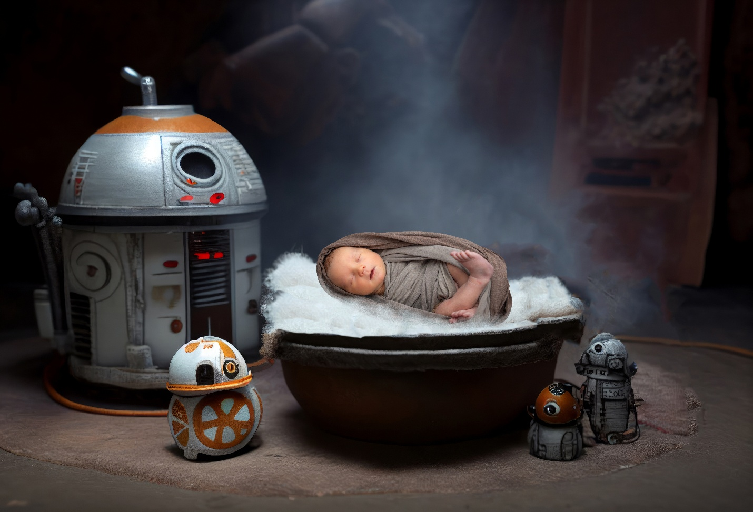
Reference
[Thomas]. (2026). aa.jpg [Photograph]. Microsoft Photos.

